|  |  |
| --- | --- |
| **Applicant work permit** | |
| **Date of request** |  |
| **Company name** |  |
| **Contact** |  |
| **Telephone number** |  |
| **E-mail address** |  |
| **Duration and description** |  |
| **Kind and number of equipment** |  |
| **Date of execution of work** |  |
| **Date end of work** |  |

|  |  |  |  |
| --- | --- | --- | --- |
| **Performer of the work** |  | | |
| **Companyname** |  | | |
| **Contactperson / foreman** |  | | |
| **Telephone number** |  | | |
| **E-mail address** |  | | |
| **Names of employees** |  | **Name** | **First name** |
| *For more than 4 employees, a separate list of names must be provided* | **1**  **2**  **3**  **4** |  |  |

|  |  |
| --- | --- |
| **RST data** | |
| **Permit number** | **WV237x** |
| **Location work** |  |
| **Contact person RST** |  |
| **Telephone number** |  |
| **E-mail address** |  |
| **Contact person QHSSE-RST** |  |
| **Telephone number** |  |
| **E-mail address** | [**werkvergunningen@rstbv.nl**](mailto:veiligheidsteam@rstbv.nl) |

|  |  |  |
| --- | --- | --- |
| **High-risk work** | | **Explanation required** |
|  | Hotwork (open flame, sparks, **location hotwork**) |  |
|  | Working at height |  |
|  | Work with/near hazardous substances |  |
|  | Special lifting activities |  |
|  | High and low voltage |  |
|  | Working within operational area |  |
|  | Working in containerstack |  |
|  | Working on moving material |  |
|  | Working on the quay |  |
|  | Work alone |  |
|  | Working in confined space |  |
|  | Bridging security |  |
|  | Different, namely |  |
|  |  |  |
|  |  |  |

|  |  |  |
| --- | --- | --- |
| **Identified risks** | | **Explanation required** |
|  | Fire |  |
|  | Collision hazard |  |
|  | Risk of falling |  |
|  | Entrapment |  |
|  | Electrocution |  |
|  | Noise |  |
|  | Explosion |  |
|  | Suffocation |  |
|  | Exposure of hazardous substances |  |
|  | Different, namely |  |
|  |  |  |

|  |  |  |
| --- | --- | --- |
| **Mandatory control measures** | | **Explanation required** |
|  | Submit V&G Plan and/or TRA |  |
|  | Start work consultation / LMRA |  |
|  | Informing persons working within and adjacent to the work area |  |
|  | Extinguishing agents |  |
|  | Dropping off workplace |  |
|  | PPE (which one?) |  |
|  | (Gas) measurements |  |
|  | Fall protection |  |
|  | Ventilation |  |
|  | Continuous monitoring |  |
|  | Lock out – tag out (LoTo) |  |
|  | Different, namely |  |
|  |  |  |
|  |  |  |
|  |  |  |

|  |  |  |
| --- | --- | --- |
| **Check** | **Date** | **Signature** |
| **Work permit approval** |  |  |
| **Issuing a work permit** |  |  |
| **Taking in work permit** |  |  |
| **Work permit check** |  |  |
| **Name client RST** | **Name of executor / Company** | |
|  |  | |
| **Signature RST** | **Signature executor** | |
|  |  | |

*By signing, the recipient indicates that all risks and necessary security measures have been identified and that all described security measures aretaken and maintained. After completion of the work or hand in this work permit to the client RST. In case of calamities, leave the workplace safely and report it at the meeting point.*

**Map of the facility**

A map of the facility is shown below. Carry out your work at the indicated marked location(s)..

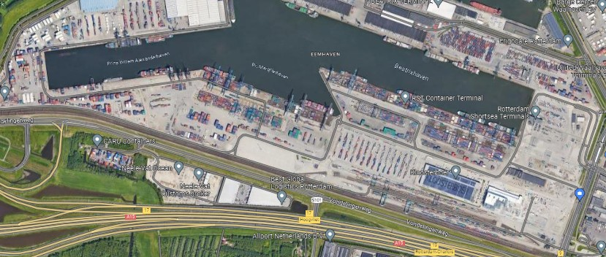

**Evacuation information**

Inform yourself and your colleagues of the escape routes before beginning your work

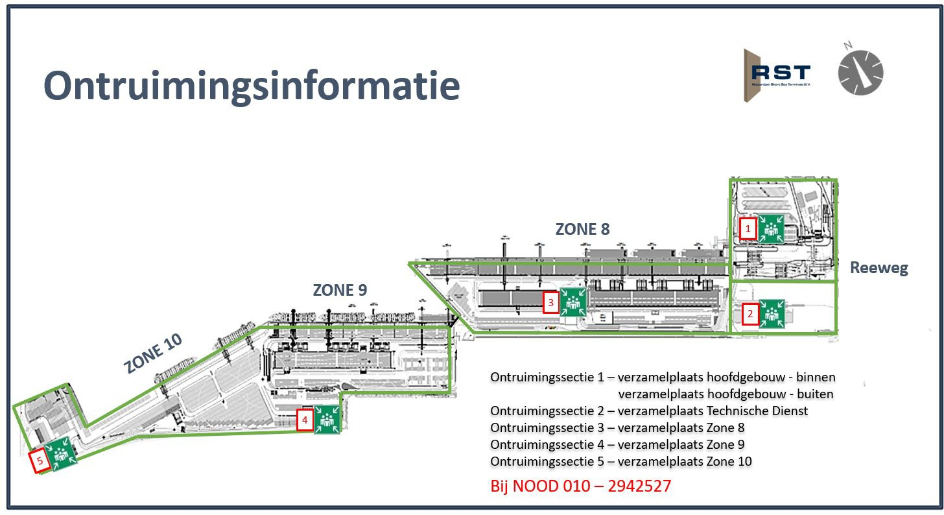

(Evacuation)









